Requirement 1
I’m Power BI Developer and working new power bi report. I wanted to use Git and GitHub to maintain version control and also to rollback for the previous versions if needed.
Solution
1, Create a Main folder in Local Machine Can be anywhere.
Ex. GitDemo . Folder name can be anything.
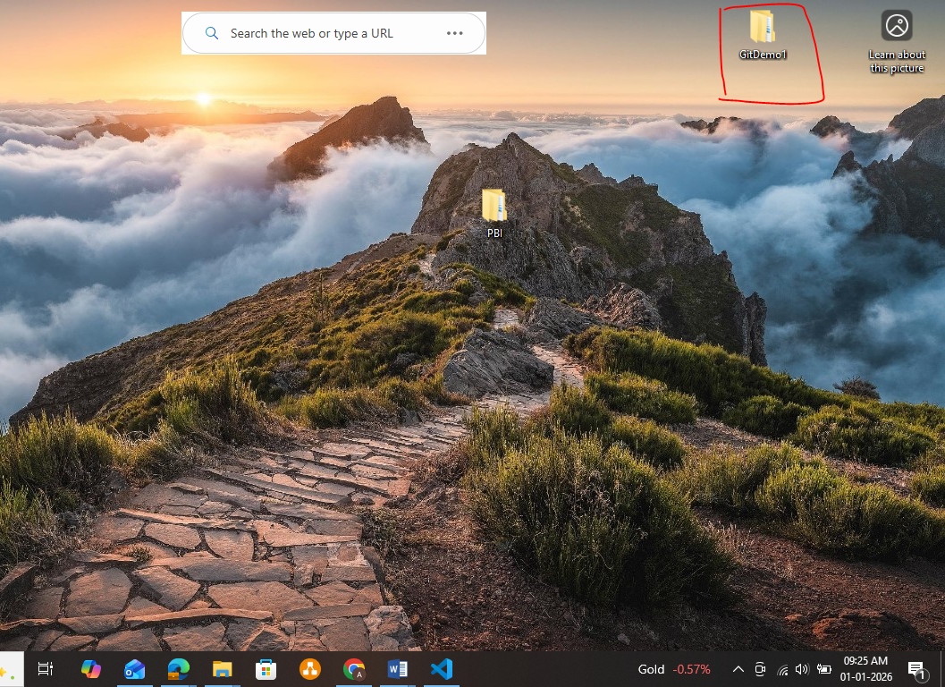
2, Go to Visual Studio Code >>File >> Open Folder
3, once you load the created GitDemo folder inside VS Code it will be available in Explorer.
4, Go to Terminal (If you can’t see go to 3 dots in explorer >> Terminal) >> Run the below command to create another folder inside GitDemo for specific report.
Command is mkdir JAN01 (Command – mkdir, Folder – JAN01)
6, If you are already in existing folder inside GitDemo folder then run the below command.
Command is Cd .. (Command – cd ..) – it will go to previous folder
Then create new folder inside GitDemo folder
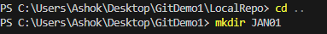
7, Now, I have created new folder called JAN01 and I wanted to go to JAN01 folder.
8, Now, check this JAN01 folder is monitored by .git or not
9, After, running this command, if you don’t see like below then this folder is not under .git
10, Now, it’s time to start monitored the folder by .git then only we can track our changes
11,Now, check this folder is monitored by git or not
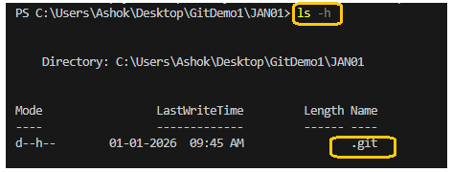
Now this folder is monitored by .git
12, Now, we have the folder in local monitored by .git and this folder data need to move GitHub repository for that we need to create new repository in GitHub
13, Go to GitHub.com >> go to profile >> Repositories >> repo name {Ex. TestJan01}
14, Now we have GitHub repository
15, Then connect to GitHub repository from VS Code (CommandPrompt) to push data from local directory (JAN01) to GitHub repo (TestJan01)
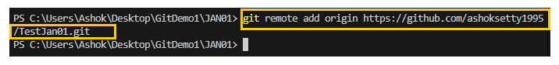
16, Check this is connected to GitHubRepository or Where it is connected
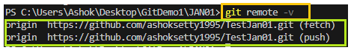
Now this is connected to my Origin GitHub repository
17, Now, git is connected to master branch and I wanted to change it to main branch to push my code
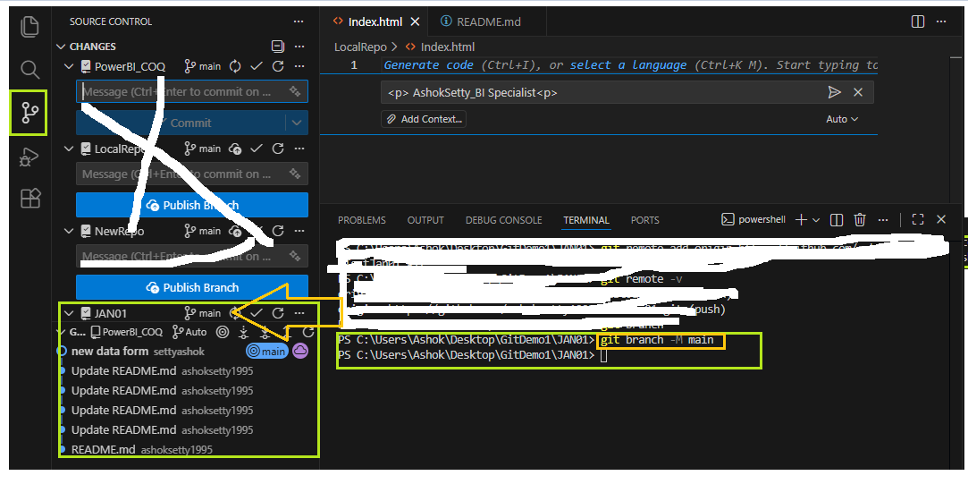
Now it is connected to main branch
18, Now I wanted to push the code to main branch which is there in local directory file name called GitAndGitHub Requirement1
19, if you notice Local directory file is untracked by .git and we wanted to make it track by .git using ADD command.

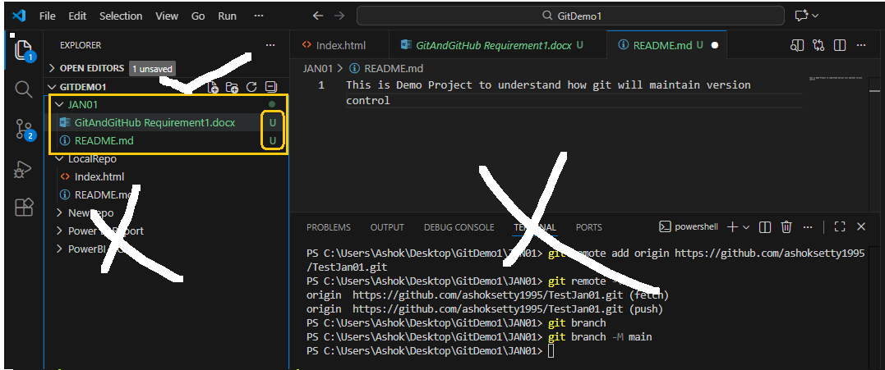
Now there are 2 untracked files by .git and we wanted to make it tack to push these 2 into github repository.

20, How to Track these 2 files , - I have 2 untracked files hence use the below command
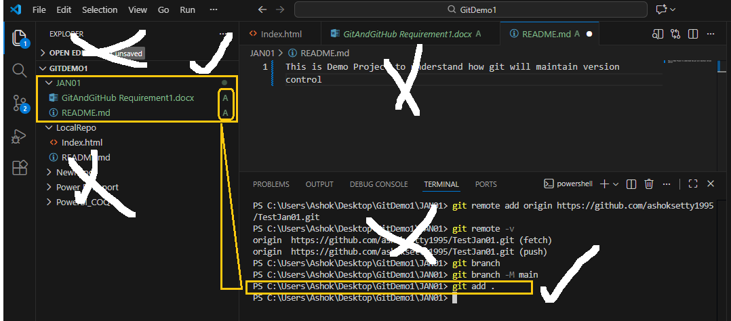
21, Now commit the file using below command
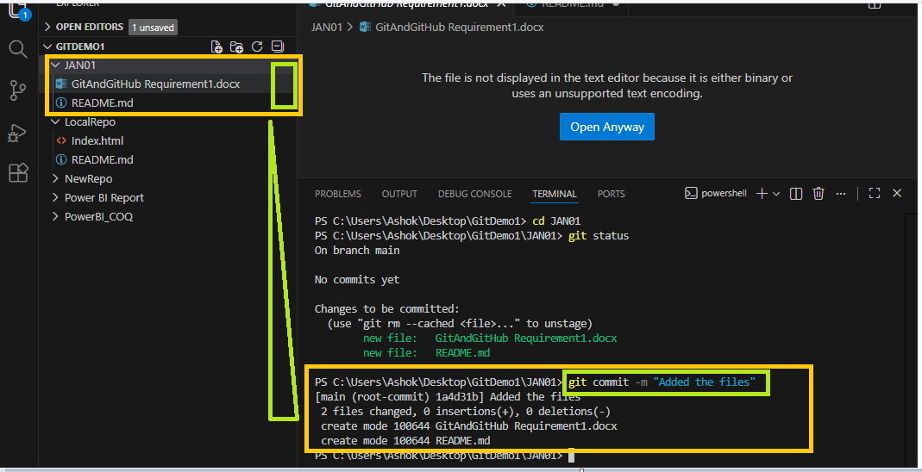
Once you commit the with Comment then you are ready to push the code into GitHub repository.
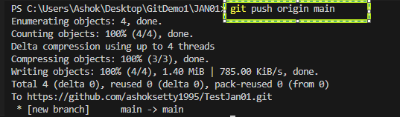

22, Now the code is pushed to GitHub Repository. Go to GitHub.com >> refresh the tab >> you can see the files under your repository
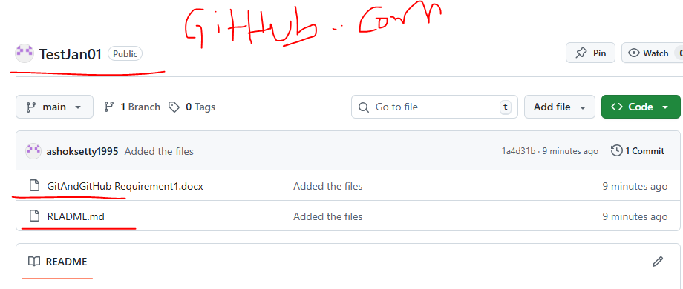
Now the code is available in GitHub.com

I have files in GitHub Repository. I wanted to take that files and modify the data and push it back to GitHub Repository
1, Get the files from GitHub Repo into your local machine folder (can be new folder or existing folder) using clone command. I have existing folder called Demo
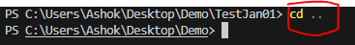
2, Create new folder called 123 in Demo folder using mkdir command
